Subnetting (Troubleshooting 1)

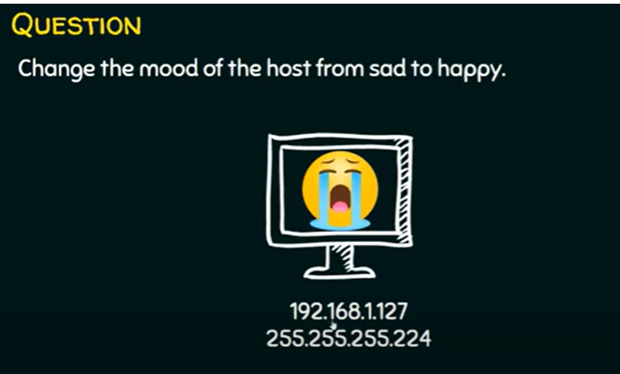

This computer is sad because it cannot communicate with neighbour computers. WHY?

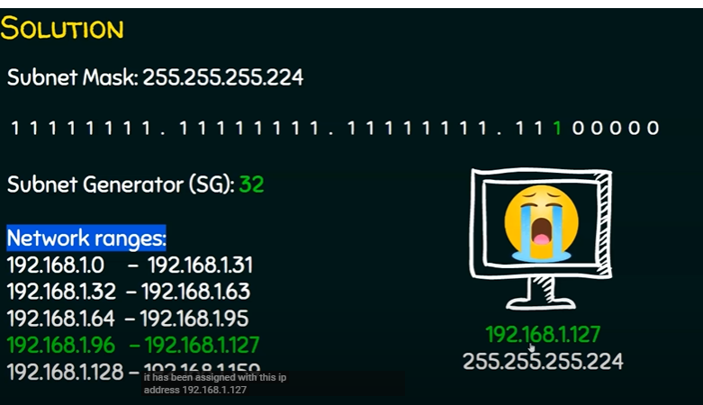

IP address is broadcast address so it cannot be used. Solution:change the IP address.